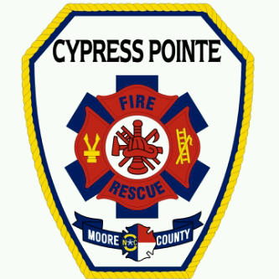
Cypress Pointe Fire & Rescue

P.O. Box 129 – 131 S. Alma Street Phone 910.245.7974
Vass, North Carolina 28394 Fax 910.245.3723
October 10, 2020
Cypress Pointe Fire/Rescue Improves Their ISO Rating

Today, Cypress Pointe Fire/Rescue has announced an improvement of their Insurance Services Office (ISO) Public Protection Class (PPC) rating. The North Carolina Office of the State Fire Marshal’s (NCOSFM) conducted an ISO Ratings Inspection on July 27, 2020.
NCOSFM utilizes the Fire Suppression Rating Schedule to measure the major elements of a community’s fire-suppression systems and develops a numerical grade called a Public Protection Classification. ISO assigns a rating from 1 to 10. With 1 being the best and 10 the worst. Ratings are determined when NCOSFM conducts an inspection that examines four areas: the fire department itself, the community water supply, emergency communications and community risk reduction.
Previously, Cypress Pointe Fire/Rescue was rated a 6/9 which equated to a Class 6 within 5 miles of one of their stations and a Class 9 for anyone beyond 5 miles from a station. Effective Friday, January 1, 2021 Cypress Pointe’s new rating will be a Class 4/9.

A Class 4 applies to properties with a fire flow of 3500 gpm or less. Class 9E applies to all other properties within the fire district outside of the 5 miles, but no more than 6 miles.
Most insurance companies use the PPC rating to determine the fire insurance premiums for commercial and residential properties within a community. A reduction in the PPC can lead to a savings on insurance premiums for property owners.
In a letter from the North Carolina Insurance Commissioner and State Fire Marshal Mike Causey he stated “Congratulations on your recent improvement to your fire suppression rating! I commend you and your department for your dedication and commitment to making your community a safer
place to live”.
Fire Chief Mike Cameron stated “I am proud of the dedication and commitment of the men and women of Cypress Pointe Fire/Rescue. Many of which live in our community and have a deep desire to serve and support our citizens. This improved rating helps to validate the excellent service they provide and has a direct impact on our citizens. This dedication is even more impressive when you realize that CPFR does not have any full-time staff members”.
NCOSFM evaluates and classifies over 1,200 North Carolina Fire Departments utilizing the Fire Suppression Rating Schedule. The grading process not only evaluates the fire department but also the Moore County 911 Center, municipal and county water systems, and portions of the Moore County Fire Marshal’s office.

